Medium Thickness Plate Servo Feeder
NCBF-400A

Technical Description

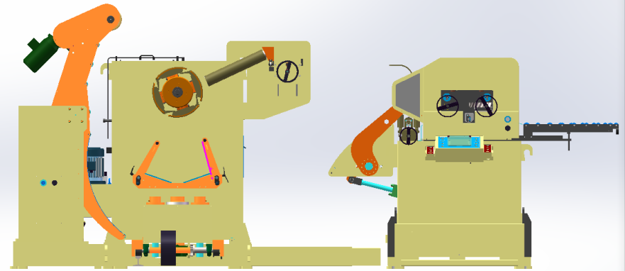

Shenzhen Lihao: Industrial Park, No. 454 Jinbi Road, Biling Street, Pingshan District, Shenzhen, Guangdong Province
Hunan Lihao: Building 1, Intelligent Equipment Industrial Park, Changfeng Avenue, Yongzhou Economic Development Zone, Hunan Province
website: www.lihaojixie.cn

Preface
Lihao Machinery Equipment Co., Ltd. is continuously committed to the research and manufacturing of stamping automation, and regards the three in one servo feeder as its core product to continuously optimize and improve its technology. After years of effort and accumulation, according to customer needs, Lihao Machinery has developed a series of standardized machinery such as NCHF thin plate type, NCMF medium plate type, NCBF medium thick plate type, NCSF thick plate type, NCLF ultra thick plate type, etc. and put them into the market. The good performance and stable quality have gained a good reputation in the industry.
Lihao Machinery has passed ISO90000:2000 quality system certification and EU CE certification. In the production process, it strictly implements standardized production and manufacturing processes and rigorous testing procedures to maximize and ensure product quality, achieving international standards.
On the one hand, Lihao Machinery continues to increase research and development investment to standardize its products, and on the other hand, due to our sufficient expertise, we are able to analyze customer needs more carefully and customize various automated stamping production lines than our peers. The feeding accuracy, equipment performance, and stability of use can all reach the advanced level of domestic and foreign peers.
Lihao Machinery has always adhered to the business philosophy of "quality first, service foremost" in its development process. While providing customers with high-quality and stable products, we also pay attention to providing professional and high-quality pre-sales and after-sales services. At present, Lihao Machinery has opened two factories in Shenzhen and Yongzhou, and has nearly 20 sales and service outlets in Shanghai, Ningbo, Wuhan, and overseas India. It has established a complete service system that can respond to customer needs within 24 hours.

Content
Medium Thickness plate servo feeder 1
Preface 2
1 Equipment Overview and New Features - 1 -
2 Equipment appearance dimensions and schematic diagram (for reference only) - 1 -
3 Suitable material parameters - 2 -
4 Equipment parameter table - 3 -
5 Corrective Ability Table - 4 -
6 Main configuration parameters - 4 -
7 Feeding speed parameter - 5 -
8 Main functions and instructions of the equipment - 5 -
8.1 The loading trolley( Optional) - 5 -
8.2 Uncoiler - 6 -
8.3 Feeding device - 8 -
8.4 Leveling feeder - 8 -
8.5 Hydraulic Shearing Machine (Optional) - 9 -
8.6 Automatic double-sided oiling machine (Optional) - 9 -
8.7 Discharge port tray device - 9 -
9 Detailed description of main technical indicators and performance - 10 -
9.1 Mechanical part - 10 -
9.2 Electrical control part - 10 -
9.3 Paint and color requirements for equipment - 11 -
9.4 Other technical requirements - 11 -
9.5 Technical requirements for safety and protection - 11 -
10 Electrical safety - 12 -
11 The excellence and comparability of the machine - 12 -
11.1 Intangible advantages - 12 -
11.2 Tangible advantages - 12 -
12 Equipment usage environment - 14 -
13 Main standards for equipment design and manufacturing execution - 14 -

1 Equipment Overview and New Features

This equipment is a three in one servo leveling and feeding machine developed specifically for stamping production of medium thick plates with wide material widths and high yield strength of material belts; The feeding roller and leveling roller of the equipment have undergone special treatment, resulting in high hardness, wear resistance, and long service life; The surface of the drum is treated with electroplated hard chromium, which increases the smoothness of the roller surface. A small number of special materials are treated with sandblasting to ensure that the feeding accuracy is not affected by slipping during the feeding process (users need to be aware of the hidden danger of inaccurate feeding if the material surface is coated with too much oil); The discharge port is equipped with a new automatic oiling device (optional), and the oiling roller is a soft wool felt roller, which can facilitate the protection of the material surface and the uniform coating of the oil layer. Using Japanese servo motors to ensure high-precision feeding; The operation panel adopts a color LCD display, a large-sized touch screen, high-definition operation images, and is equipped with an operation safety protection system, allowing even first-time users to operate with peace of mind; A user-friendly design for a sound operating system can shorten the preparation work. Advanced automatic diagnostic system assists operators in quickly controlling the outstanding performance of the machine; The design concept of enhancing safety factor extends the safe service life of equipment.

2 Equipment appearance dimensions and schematic diagram (for reference only)
(1) Maximum length of equipment: approximately 5500mm
(2) The maximum width of the equipment is about 3100mm
(3) Maximum height of equipment: approximately 2700mm

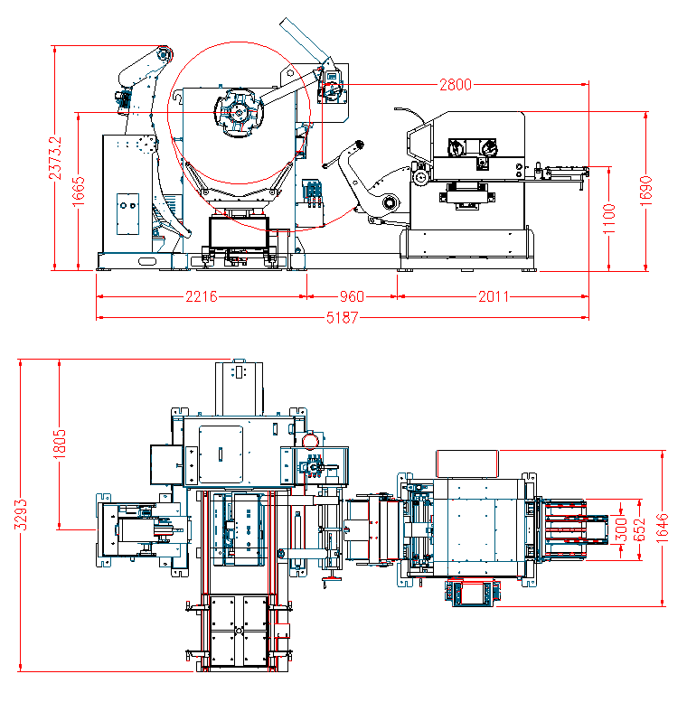

3 Suitable material parameters
Material: Cold rolled plate, pickled plate, hot-rolled plate, stainless steel
Material surface treatment: no treatment
Material thickness: 0.5-4.5mm (please refer to the material correction capability table)
Material broadband: 100-400mm
Yield strength: ≤ 590N/mm²
Roll inner diameter: 508mm
Roll outer diameter: ≤1600mm
Roll quality: 3T

4 Equipment parameter table

project | unit | parameters
Material width | mm | 100-400mm
Material thickness | mm | 0.5-4.5mm
Maximum material weight | Kg | 3000
Roll inner diameter | mm | Φ508
Roll outer diameter | mm | Φ1050-Φ1600  （For outer diameters less than 1050, please specify in advance）
Correction roller | pieces | 7 pieces Up 4/Down 3, diameter 68MM
Feeding roller | pieces | 2 pieces Up 1/Down 1, diameter 84MM
Air pressure | Mpa | 0.55-0.60
Servo motor | kw | AC 4.4kw
Rack motor kw | kw | AC 2.2kw
The height of the feeding line | mm | the customer requires ± 100 (important parameter, to be filled in by the customer)
Feeding accuracy | mm | When 0-400,±0.2, Over 1000 ± 0.3
Expansion range | mm | Φ460-Φ530
Expansion method |  | Hydraulic expansion
Feeding direction |  | from left to right/from right to left (important parameter, to be filled in by the customer)
Using materials |  | Hot rolled plate, cold-rolled plate, pickled plate, stainless steel
Working power |  | AC380±10%,50HZ,three-phase five wire system
Machine color |  | according to catalog (host RAL9010), yellow for protective and movable parts

5 Corrective Ability Table
yield point stress （N/mm²） |  | 245 | 368 | 490
tensile strength（N/mm²） |  | 392（40kgf/mm²） | 488（50kgf/mm²） | 580（60kgf/mm²）
thick plate  （mm） | 1.2 | 400 | 4O0 | 300
thick plate  （mm） | 1.4 | 400 | 400 | 300
thick plate  （mm） | 1.6 | 400 | 320 | 240
thick plate  （mm） | 1.8 | 400 | 266 | 200
thick plate  （mm） | 2.2 | 320 | 213 | 160
thick plate  （mm） | 2.8 | 250 | 166 | 125
thick plate  （mm） | 3.2 | 220 | 146 | 110
thick plate  （mm） | 4.5 | 150 | 100 | 75

6 Main configuration parameters
No. | name | brand
1 | Reduction motor | Xinhua
2 | Servo Motor | Yaskawa
3 | Touchscreen | Weilun
4 | PLC Programmable Logic Controller | Mitsubishi
5 | circuit breaker | Schneider
6 | contactor | Schneider
7 | Control button | Hequan
8 | relay | Schneider
9 | Pneumatic components | Sanchi
10 | Hydraulic Station | Chuanglibo
11 | Photoelectric sensing | Omron
12 | Cylinder | Sanchi
13 | Leveling bearing | NSK
14 | Frequency converter | Sanke
15 | Servo Drive | Yaskawa

7 Feeding speed parameter
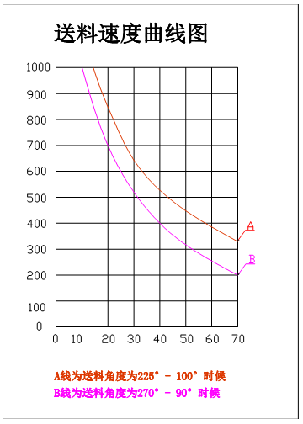
Feeding speed curve chart
Line A represents the situation when the feeding angle is between 225 ° and 100 °
Line B is the situation when the feeding angle is 270 ° -90 °

8 Main functions and instructions of the equipment
8.1 The loading trolley(Optional)
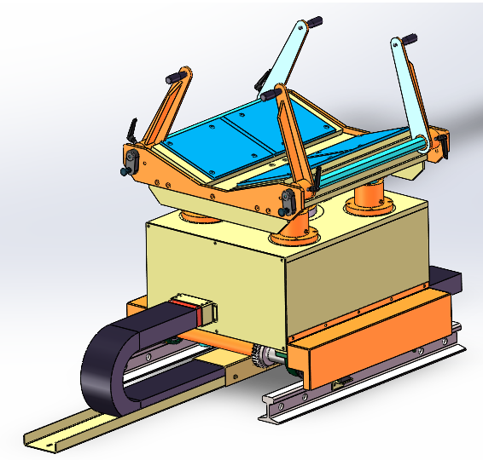
（1）Function description: Used to smoothly transfer the material roll to the main shaft of the material rack, preventing the material roll from hitting the main shaft or body of the material rack due to excessive inertia during the lifting process. In addition, the trolley can also be used to lift the material end during unwinding and feeding, so that the material strip can smoothly enter the leveling machine. The trolley is equipped with a roll anti tipping baffle, which can effectively prevent the roll from tipping when transferring smaller materials.
（2）Material seat shape:The bearing surface is a V-shaped structure
（3）Vehicle load capacity:3000kg
（4）Trolley walking drive: hydraulic motor (throttle valve adjusts speed)
（5）Trolley lifting drive: hydraulic cylinder (pressure holding valve control can run smoothly with load)
（6）Roll alignment method: Handheld operating handle (visual alignment, equipment with scale for reference)
（7）Trolley travel anti offside: travel switch with hard limit block
（8）Anti dumping baffle movement method: manual adjustment
（9）Trolley movements: There are four movements: forward, backward, up, and down, which are operated through a wireless remote control handle.

8.2 Uncoiler
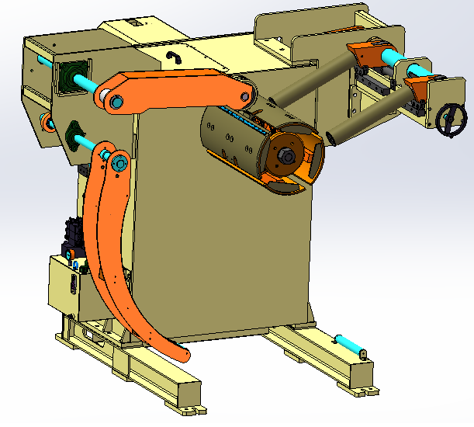
(1) Function description: The unwinding machine is a support that fixes the material roll on the main shaft of the material rack by expanding and shrinking the inner diameter of the support material roll
During automatic operation, the worktable uses a photoelectric sensing device to intermittently rotate the spindle for unwinding and discharging. This includes the main shaft expansion and contraction part, the pressing arm part, the blocking arm, the supporting arm, and the photoelectric sensing part.
(2) Roll width: 100-400mm
(3) Material rack load: 3000kg
(4) Expansion method: hydraulic linkage expansion
(5) Spindle expansion range: Φ460-Φ530
(6) Spindle drive motor: AC motor with frequency converter
(7) Spindle transmission method: Variable frequency reduction motor, double row large pitch chain transmission
(8) Spindle brake: disc brake
(9) Main axis unwinding direction: feeding from bottom to top (counterclockwise for standard left-hand machines)
(10) Roll pressing arm: compresses the material while preventing the roll from becoming loose after removing the straps, and also prevents the roll from popping open and injuring the operator at the moment of unfastening the packaging buckle.
(11) Roller specification: PU rubber wheel
(12) Pressure wheel drive mode: active type
(13) The action mode of the pressing arm: pneumatic drive, can be manually raised and lowered, and during automatic operation, it can be used or not used according to the thickness of the material. The feeding arm is equipped with power, which can reverse winding to prevent loose materials.
(14) Material blocking arm: located in the upper right corner of the material rack, the wheel surface of the material blocking wheel is close to the side of the material roll. The blocking wheel can rotate freely with external forces without power, and is used to prevent the material belt from sliding sideways during the feeding process, which may cause scratches and induction failure.
(15) Material width adjustment: manual screw adjustment
(16) Material blocking arm action: The pneumatic drive causes the outer material blocking wheel to move up and down, while the inner material blocking wheel does not move and only moves in the width direction of the material roll. The action of the outer limit wheel is limited to manual operation on the touch screen, and it must be in the lowered position before automatic operation.
(17) Material support arm: It supports materials for easy feeding and is driven by pneumatic means. It can be manually raised and lowered. During automatic operation, the material support arm must be in the lowest position.
(18) Material loop control: The infrared photoelectric sensing switch below the feeding arm senses the feedback signal of the material belt by shading or not when it droops, to control the start and stop of the unwinding machine spindle, ensuring sufficient and reasonable buffer arc between the unwinding machine and the leveling feeder, and ensuring that the feeder has sufficient feeding allowance.
(19) Tile scale indication: The tile surface is milled with grooves, and a built-in scale is used for easy alignment during loading.
(20) Tail guide: There is an assembly tail guide device under the tile to prevent the tail from rolling back into the expansion and contraction parts, causing reverse rotation and resulting in feeding failure.

8.3 Feeding device
(1) Function description: When threading, the feeding drum can be manually opened and closed, and with the help of a hydraulic trolley, the material head can be smoothly, easily, and safely clamped and guided from the unwinding machine to the leveling wheel.
(2) Feeding swing arm drive: cylinder drive, touch screen inch button operation
(3) Feed roller drive: Gear transmission and leveling feeder share power, and the drive gear of the feed roller is a special pointed gear
(4) The transmission gears of the two rollers can smoothly combine during the opening and closing action.
(5) Feeding drum: 2 (surface plated with hard chrome, HRC60 ± 2)

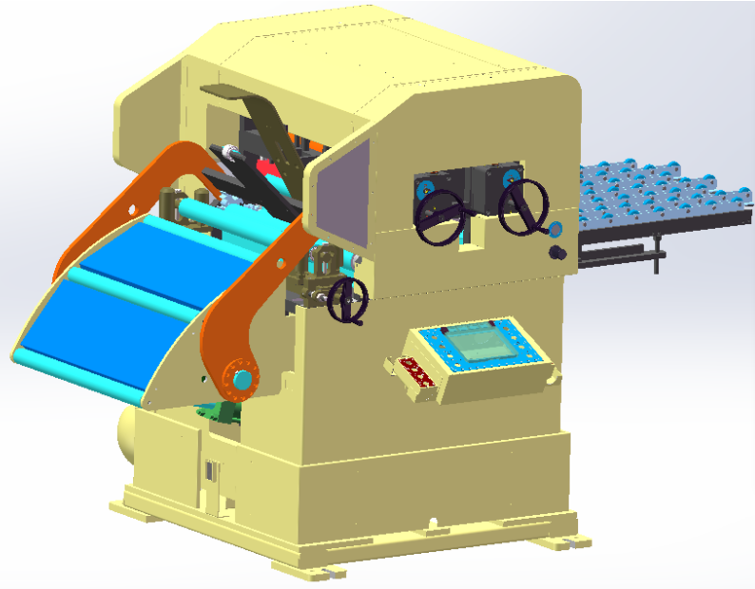
8.4 Leveling feeder
(1) Function description: This mechanism is mainly used to correct the length direction of the material roll, make its surface flat, and feed the material into the pressure equipment according to the set length and speed. When there is local stretching phenomenon on the surface of the material, it may not be completely corrected. Additionally, it is not possible to correct the width direction of the coil material.
(2) Drive mode: AC servo motor
(3) Correction rollers: 7 (4 on top and 3 on bottom, surface thickened electroplated hard chrome grinding treatment HRC60 ± 2) Upper correction with eccentric leveling roller: 1 (surface thickened electroplated hard chrome grinding treatment HRC60 ± 2), the height of the roller surface can be independently adjusted to change the direction of discharge up or down, thus solving the material correction of different directions of curvature for customers.
(4) Feeding rollers: 2, (surface plated with hard chrome, HRC60 ± 2)
(5) Correction adjustment method: manual adjustment of leveling turbine worm gear
(6) Correction roller support: none
(7) Correction roller release method: pneumatic type
(8) Roller material: High carbon chromium Gcr15 bearing steel
(9) Height adjustment method for feeding line: electric adjustment, factory standard feeding line 1100-1300mm
(10) Roller drive method: Side gear drive, all gears are manufactured using a grinding machine with a 6-level precision standard for grinding
(11) Repeating accuracy of feeding: ± 0.15mm/m for 0-600mm, ± 0.3mm/m for 1000mm and above
(12) Discharge line speed: 16m/min

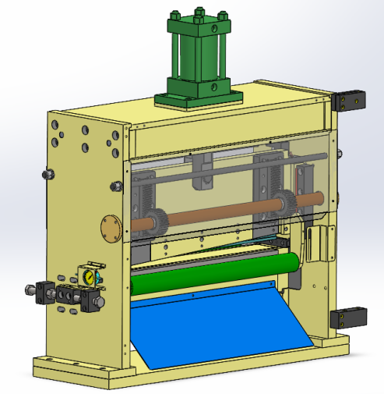
8.5 Hydraulic Shearing Machine (Optional)
- Function description: The shearing machine is mainly used for cutting the head and tail of materials
- Drive mode: hydraulic drive
- Maximum cutting width: 400mm
- Shear material thickness: 0.5-4.5mm
- Scissor gap adjustment: The scissor gap can be manually adjusted according to different material thicknesses
- Gap value display: dial gauge display

8.6 Automatic double-sided oiling machine (Optional)
- Function description: It can automatically apply double-sided oil to the surface of materials, and the continuous and intermittent oil application time can be adjusted as needed.
- After the oil is sprayed from the oil outlet pipe onto the upper and lower surfaces of the material, it is evenly applied by the machine with a wool felt wheel, and the remaining oil can be recycled and reused.
- Oil tanker material: 1 soft wool felt wheel on each side
- Oil wheel length: effective length 400mm
- Oil storage tank capacity: 12L

8.6 Discharge port tray device
(1) Function description: Install wear-resistant wheels on the material rack to ensure reliable transportation of the material belt between the press mold after sizing
(2) Width range: less than 400mm
(3) Length adjustment: There is an additional set of adjustable length wheels in the middle, which are used to match shorter mold styles. In the future, the wheels will be extended to support the material.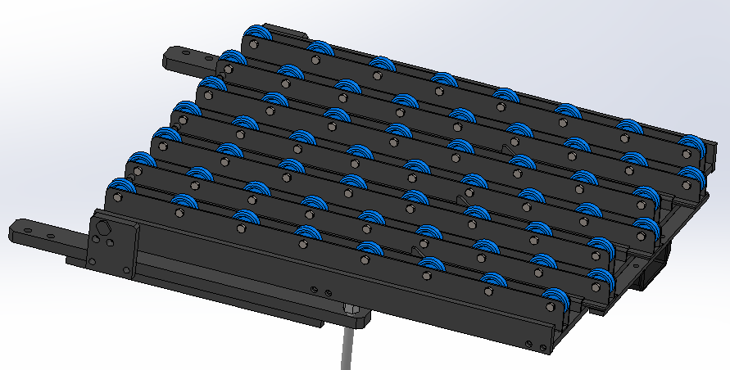

9 Detailed description of main technical indicators and performance

9.1 Mechanical part
- Machinery has a high standard principle in the selection of parts, insisting on meeting the original design standards and raw materials for assembly processes and spare parts, and never sacrificing product quality requirements for cost considerations.
- The straightening roller and feeding roller are made of high-quality bearing steel roller chromium GCr15 quenched and tempered, medium frequency quenched, precision ground and plated with hard chromium at 60 ℃, and then precision ground to obtain finished products;
- Bearings: Adopting Japanese brands such as NSK;
- Copper lining: using self-lubricating bearings or copper lining;
- Gear: 20Cr manganese titanium, precision grinding, national standard level six

9.2 Electrical control part
- We have established independent design capabilities in the electronic control system, with a complete professional design team that can grasp the specifications and needs of each machine, and plan and design high-efficiency and user-friendly electronic control systems. The new integration of machinery has enabled stamping workers to achieve high-precision and fully automated feeding in multiple directions.
- The main control adopts imported Yaskawa servo motors, Mitsubishi control systems, PLCs, and frequency converters from Japan;
- The general operation panel buttons use first-class Hequan products and anti-interference signal lines to ensure feeding accuracy. We have created an irreplaceable 'differentiated competitiveness' in the feeding equipment of large-scale automotive and 3C product manufacturing units.

9.3 Paint and color requirements for equipment
- The main tone is RAL9010, using the national standard GSB05-1426-2001 paint film color standard sample card. Outsourced components (such as electric and pneumatic components) should maintain their original colors, while other decorative colors should be based on the manufacturer's preferred style.

9.4 Other technical requirements
- All components and instruments of the equipment shall be measured in metric units.
- Due to the inevitable need for manual feeding operations in certain situations with the accompanying press, it is necessary to leave appropriate working space for operators between the discharge end of the feeder and the press. Therefore, a movable lifting platform should be equipped, and the lifting height should be consistent with the adjustment range of the discharge port height. The equipment requires good grounding effect to reduce the possibility of leakage and ensure the safety of personnel and equipment. The construction of the grounding project is the responsibility of the seller, and the cost is included in the total equipment price.
- The various types of oil necessary for the normal operation of the equipment are provided by the user unit, including 40L anti-wear hydraulic oil.
- The above requirements are the most basic requirements of the demand side, and the environmental safety indicators during equipment design, manufacturing, installation, commissioning, and operation should comply with the latest national environmental protection, emission, and occupational health standards.

9.5 Technical requirements for safety and protection
- The equipment is equipped with an automatic error detection device. Once there is a problem such as abnormal material loop control, press stop action, or other error information, it will be fed back to the equipment control system. The display screen will show the error information and process it. After the fault is eliminated and the alarm is cleared, the action will be restored.
- The equipment has complete protective devices, and the design of the protective devices should comply with the latest national safety standards. (Separate protection for moving parts, trachea, wires, and cables).
- The equipment must have an emergency stop switch, installed in a location that is convenient for emergency operation, and the switch color is red.
- The dangerous parts of the equipment must be marked with text and danger graphics.
- Equipment and facilities should comply with ergonomics and minimize the labor intensity of operators.
- The power switch and air source switch of each electrical cabinet should be able to be locked.
- During equipment operation, various lubricants and components that may splash or be ejected must be protected, and the strength of the protective facilities must meet the protection requirements. The moving parts exposed outside the equipment must have protective devices.

10 Electrical safety
- Electric control cabinet: The electric control cabinet is made of metal sheet metal structure and has sturdy metal door panels and locks to prevent unauthorized opening. External handle type
- Power main switch: installed on a dedicated mounting plate on the inner side of the electrical control cabinet, with the switch handle exposed to the outside of the box.
- Emergency stop switch: The emergency stop button is located on the front of the operation box and is red in color. It has the function of "pressing the self-locking rotation reset". The emergency stop function is interlocked with the punch press emergency stop, but it will not affect the normal operation of other equipment in the same workshop.
- Abnormal alarm: When the device encounters an abnormality, the screen will display the fault content and solution, and at the same time, the punch press will be controlled to enter an emergency stop state. After troubleshooting, the emergency stop will be automatically released.
- Component layout: Component layout should pay attention to layout planning, grouping and placing components with similar functions, and considering heat dissipation and electromagnetic compatibility. Heating elements need sufficient heat dissipation space, and high-voltage and high current lines should be separated from low-voltage signal lines as much as possible to reduce interference. The wiring should be neat and comply with specifications, and all components and circuits should be clearly labeled. Adhere to relevant electrical standards to ensure easy access and maintenance of components.
- Cables and circuits: The circuit is equipped with protection functions such as short circuit protection and overload protection. External cables of the equipment are wrapped in cable trays or flexible conduits, and some cables are supported by energy guiding chains.
- Power distribution: The 24V switch power supply adopts a power supply with noise filtering to reduce electromagnetic interference, ensure stable system operation, and improve anti-interference ability.

11 The excellence and comparability of the machine

11.1 Intangible advantages
- We have a professional R&D team, with a design philosophy based on Japanese design, high safety factor, and long service life.
- After sales service is considered based on long-term cooperation, with a fast response time and usually problems can be solved on the same day.
- There are many quality management personnel and requirements for component testing.
- High processing accuracy is required, and every part should strive for excellence.
- Most of the components (including electrical) are mainly from Taiwan and Japan.

11.2 Tangible advantages
- The use of a top 4 and bottom 3 structure makes it easier to adjust the flatness, and the fourth one adopts a movable eccentric drum, which facilitates the adjustment of the feeding direction of the coil material and provides users with an extra layer of protection;

- The leveling roller and feeding roller are solid rollers, made of high-quality bearing steel as raw material. After heat treatment and quenching at HRC 60 º, they are plated with hard chromium twice and ground, resulting in high hardness, wear resistance, and long service life. High precision rollers can ensure the purpose of eliminating material stress and leveling materials;

- Transmission method: Adopting synchronous belt transmission mode, the turbine reducer type reduction structure is not selected for high power, which can avoid the situation of inaccurate feeding caused by subsequent reducer clearance and high maintenance costs.

- Anti roll function of the material rack: The material rack is equipped with anti roll function to prevent the material head from reversing when using tail materials due to the material head being rolled back.

- Both the side panels and tiles are made of precision machined steel plates, and cast iron or even cast steel structures commonly used in the industry are not selected to prevent deformation and damage of the screw threads during maintenance and disassembly after gluing, or damage to the tiles and machine heads caused by collisions.

- Observation hole: There is a reserved observation hole for the material head, which can facilitate the operator to observe the position of the material head and prevent the material head from being trapped and difficult to remove due to the inability of some employees to detect overpressure and material jamming in a timely manner due to unskilled operation.

- Feeding drum: After long-term experience accumulation, the structure of the feeding drum has been overturned, making it more stable, convenient, and without any sequelae.

- Tile structure: The tiles are cut from seamless steel pipes with an outer diameter of 508, ensuring the uniformity of the inner circle and preventing waste caused by the deformation of the inner ring due to linear contact of thinner and softer materials when used.

- Discharge roller: Adopting a retractable wheel structure, it is convenient to switch between molds of different lengths, and extends the feeding device as far forward as possible to the entrance of the mold.

- The appearance of each model is finely crafted, with sheet metal being bent and processed as much as possible without welding. The design is reasonable, and the sheet metal is all baked in paint, with beautiful colors. The paint tone can be changed according to customer needs to achieve consistency with the host. Can better enhance the image and influence of your company;

- The trolley and mold adjustment handle are all equipped with wireless remote control handles to avoid the trouble of dragging wires, and the site is clean and beautiful.

- Material blocking arm structure: The unique material blocking arm structure can prevent the deformation of the screw rod caused by the impact of materials, resulting in the inability of the screw rod to shake.

- Material pressing arm structure: The power type material pressing arm structure is perfectly matched with the material rack discharge motor, and there is almost no situation of loose material in the material rack.

12 Equipment usage environment
- Usage environment:- 10 °C +45°C
- Relative humidity: ≤ 95%
- Working environment power supply: 380V 50HZ three-phase five wire system
- Air pressure: 0.5MPa
- Equipment power: approximately 16 KW
- Production direction: from left to right (can be made according to customer requirements)

13 Main standards for equipment design and manufacturing execution
- GM/26485-2011 Open book Leveling Line Safety Requirements
- GM4051-91 Technical Conditions for Working Rollers of Metal Sheet Correction Machine
- Technical specifications for JM/T3164-94 roll type sheet metal straightening machine;
- JM/T1465.1-1999 Basic Parameters of Roller Plate Correction Machine
- GM/T5226.1-1996 Industrial Machinery Electrical Equipment Part 1: General Technical Conditions
- GM/T1576-1995 Mechanical Safety
- GM/3766 General Technical Conditions for Hydraulic Systems
- JM/T5000.1-1998 Product Inspection
- JM/T5000.9-1998 Cutting Processing
- JM/T5000.10-1998 Assembly
- JM/T5000.12-1998 Painting


Shenzhen Lihao: Industrial Park, No. 454 Jinbi Road, Biling Street, Pingshan District, Shenzhen, Guangdong Province
Hunan Lihao: Building 1, Intelligent Equipment Industrial Park, Changfeng Avenue, Yongzhou Economic Development Zone, Hunan Province

深圳力豪：广东省深圳市坪山区碧岭街道金碧路454号
湖南力豪：湖南省永州经济开发区长丰大道智能装备产业园1#栋
网 址：www.lihaojixie.cn

